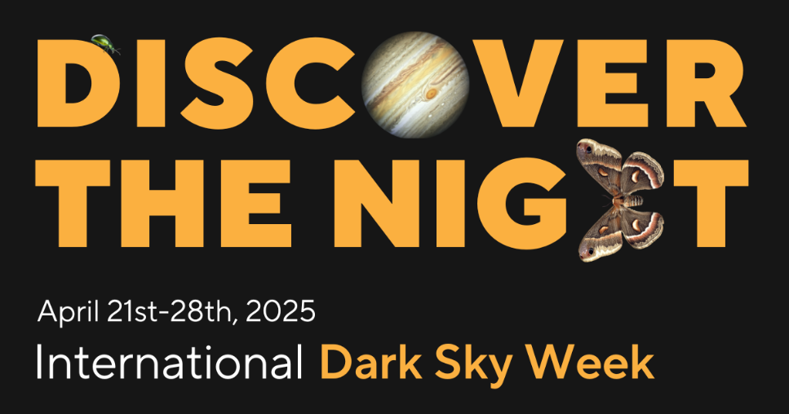
What do we want to see at night, a bunch of bright glaring lights, or billions of twinkling stars? The choice is ours!
Worldwide celebration of the night sky providing a time to reflect upon
the importance of reducing light pollution and restoring a more natural nighttime environment, filled with stars! We can flip the switch on light pollution!
DarkSky San Diego County invites everyone to step outside
and gaze upward to celebrate International Dark Sky Week!
VISIT: o Santa Ysabel Nature Center’s ‘Dark Skies’ exhibit
o Palomar College Planetarium ‘The Sky Tonight’ or full dome movie
Star Party & Lyrids Meteor Watch astronomers, films, poetry, birdwatching, more!
- Saturday, April 19 - Los Penasquitos Ranch House (6:00 – 10:00 p.m.)
- Thursday, April 24 - Mission Trails Regional Park Visitor Center (6:00 – 9:30 p.m.)
- Friday, April 25 - Sycamore Canyon/Goodan Ranch in Lakeside (dusk until 10:30 p.m.)
- Saturday, April 26 - Worldbeat Cultural Center in Balboa Park (6:00 – 10:00 p.m.)
- Saturday, April 26 - Fallbrook at William Frazier Elementary (7:00 – 10:00 p.m.)
- Saturday, April 26 - Borrego Springs at Old Springs County Preserve (8:00 – 10:00 p.m.)
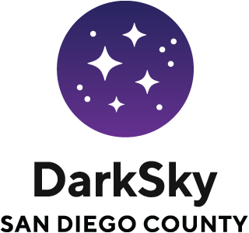
Join Events Across San Diego County
Participate at Home or Online
Visit DarkSkySanDiego.org for event details
Check out idsw.darksky.org for more info

